Robbie the Re-cycled Robot

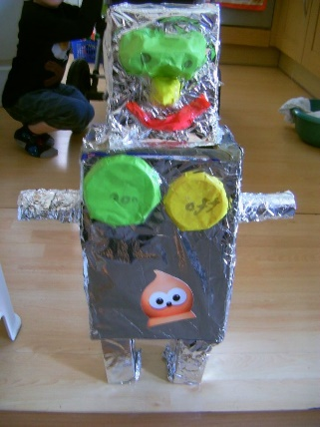
You will need:
2 different sized boxes
4 toilet rolls or kitchen rolls
Silver foil
Plastic lids for knobs and dials
Craft decorations of your choice
Felt tip pens
Tape and glue/ sticky tac
Ripped or shredded paper

How to make Robbie:
Cover your boxes and tubes with tin foil, secure with tape or glue.
Stick on your knobs and dials where you want them.
Draw a robot face and decorate as you like.
Carefully tape your robot’s arms, legs and head on.
Stick on your robots shredded paper hair using tape or glue.

