Jay-Jay the Supersonic Bus

**2015**

Author Sue Wickstead

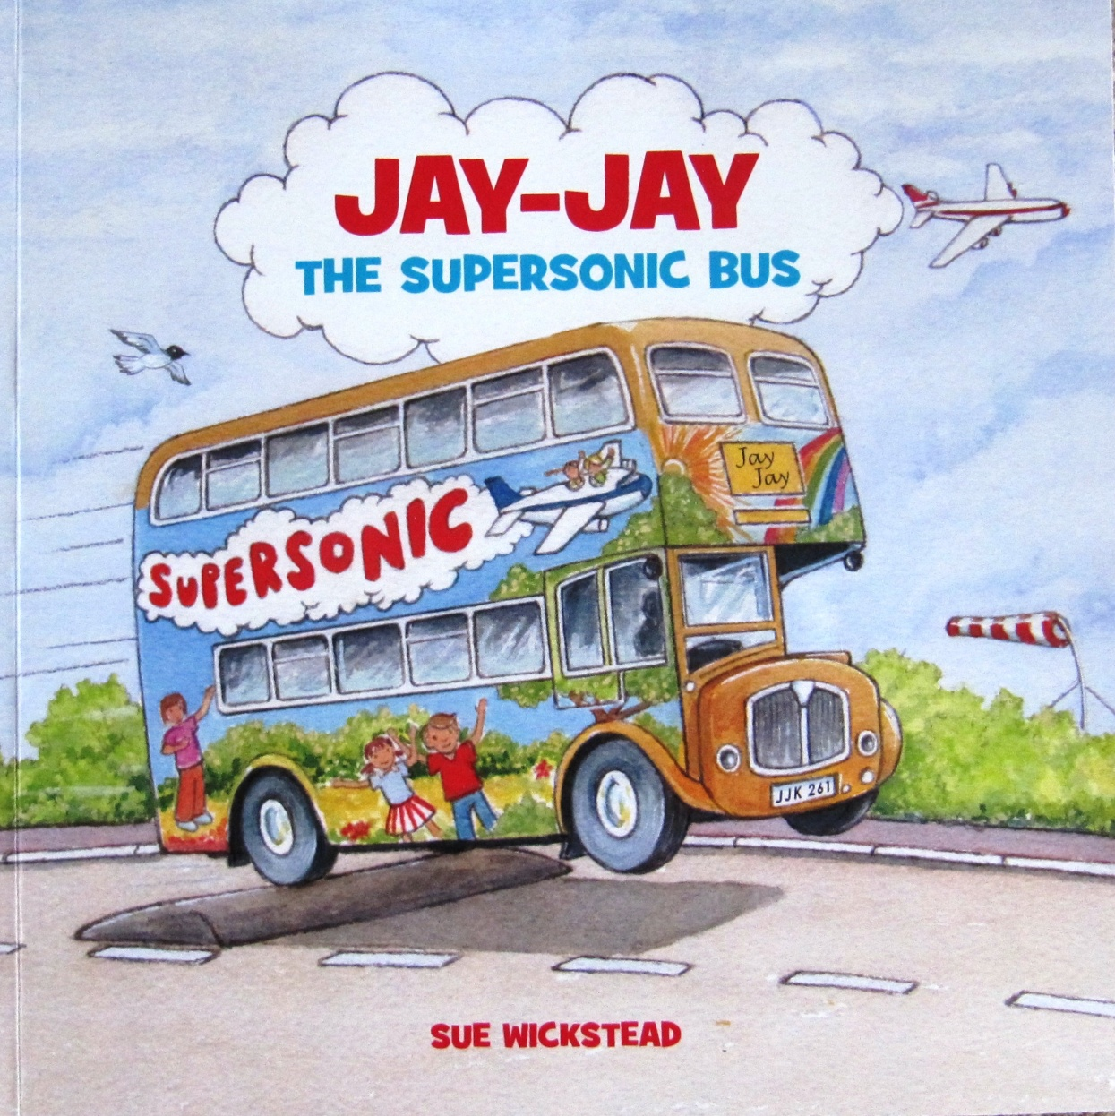

Teaching Resource ideas to compliment and support the book across the curriculum.

KS1/2

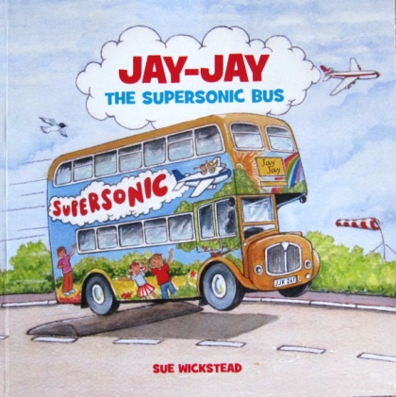**Jay-Jay the Supersonic Bus**

**Fact and Fiction**

Write a letter to the author.

What was the background to the story writing?

What was real and what was made up?

Author visits can be arranged currently available in Sussex and Surrey

By Sue Wickstead

‘Jay-Jay the bus was rescued from the scrap yard where he was sadly gathering dust and cobwebs. He is taken to an airport where he is magically transformed into a ‘Playbus’ full of toys, games and adventure.

**Design Technology**

Use the bus template to create a bright and colourful ‘Playbus’. Draw from all four sides adding headlights and number plates etc. (WS)

Use the 3D bus template to design final bus; cut out on card. (WS)

Prototype.

Use a Jinx frame or relevant materials to make a chassis with moving wheels.

Add the vehicle body to turn into a moving model.

Peer evaluation. What worked and what do you think of the final product?

Give an MOT certificate and pass rating. (WS)

Design a bus ticket. / bus pass.

**Background**

**What is a ‘Playbus?**

[www.workingonwheels.org](http://www.workingonwheels.org)

The National Playbus Association (Working on Wheels) aim to improve the quality of life for children, young people and adults who live in isolated communities or where there are poor community resources by taking a wide range of services and facilities to their local area.

**Speaking and Listening**

Remember your first day in playgroup/school when your mum left you at the door? How did you feel?

What were your favourite toys to play with to make you feel better?

What toys would you put on your bus? (WS)

**Construction**

Use construction toys to create moving buses or cars etc.

Collect model buses to sketch and play with.

Photographs

**Learning Environment/role play**

Create a role play area/ bus or waiting room.

(Add maps; timetables; chairs; caps and costumes over the topic)

Add bus stops.

**Speaking and Listening**

Using a maze map, plan a journey to get the bus to the toy shop. (WS)

What route did you take?

What did you pass on the way?

Who could get on at each stop?

Tell your friend about your route.

What other road could you have taken?

Plan and draw your own journey map.

Where will it go what will it see?

(Link to other text)

**Music**

Create a sound journey using bodies and instruments.

Songs:- Wheels on the bus

**Art**

Using the PP look at different brightly decorated mobiles. (PP)

Draw your own bus make him bright and colourful. Use a variety of media. (WS)

(Reception create a collage bus with basic window and wheel shapes)

Give him a name.

Sketch and label a bus. Look at buses through time.

**ICT**

Use control devises to follow routes. (Beebots; roamers)

**PSHCE**

Circle time discussion: How would you feel if you were unwanted and left to stand alone?

How would you feel if your hard work was valued and you received a medal or acknowledgement for your efforts?

**Maths**

**Problem solving, reasoning and Numeracy:**

Number – Addition and subtraction problems, how many passengers on the bus? Early years practical.

Word problems

Money – paying for tickets, giving change, using coins.

Money – Prices for the toys on the Playbus. What would you buy and how much would it cost? (WS)

Measures – Link to Science- How far will your bus travel under different conditions using standard and non-standard units of measure

Time – Interpreting bus timetables

Data – transport survey

**History and Investigation**

How have buses changed?

Where is the nearest sight-seeing tour bus?

Is there a local ‘mobile’ project in the area?

**Literacy**

Story-writing- Create a story map and plot events to write own story. (WS)

Write a newspaper article with headlines about Jay-Jays visit to Buckingham Palace.

Sight-seeing tour:- Write or give a commentary for your bus tour.

Think of local landmarks or sights you might pass.

Draw and write about your journey to school.

**Physical development**

Move body in different ways to represent the mechanical movements and to create the engine of a bus.

(Add fuel and build up air brakes etc)

Develop speed, strength, stamina, flexibility through PE sessions.

Plan a journey of movement.

**Design a game to play**

Use your story map to think of what sights you might pass on your road map.

What events could happen and what would be the reward/consequence?

Add details to a board template.

Make game pieces and rules.

Play and evaluate.

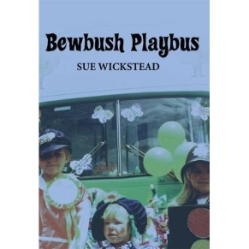

**Local links**

Is there a bus driver you could invite in?

Contact the local bus provider to find out where they operate.

Collect timetable s and leaflets.

Are they prepared to visit the school?

(Our local bus company once offered trips taking the children through the local bus wash).

Have the children ever been on a bus?

Where did they go?

Was it a single-decker or a double-decker?

Look at the History of London bus transport and how they have changed.

**Playbus/ Mobile Projects**

There were once many double-decker buses providing services across the country and around the world.

There are still many projects still in operation they are now also in vans trailers etc..

They offer a wide variety of uses from Play to mobile gyms; book buses; musical stage; church; children’s’ parties etc...

The mobile service takes the resource to where the need or demand is.

For further information contact:-

Working on Wheels (Formerly National Playbus Association)

[www.workingonwheels.org](http://www.workingonwheels.org)

**Author:- Sue Wickstead**

Web site :- [www.suewickstead.co.uk](http://www.suewickstead.co.uk)

E.mail :- [stories@suewickstead.co.uk](mailto:stories@suewickstead.co.uk)

**From Fact to Fiction**

**What’s in a name?**

Playbus; Busy bus; Fun Bus?

BBC TV once had a television programme for young children called ‘Playdays’.

It was a bus which visited 5 different stops in a week:- The Why Bird stop; the Playground stop; The Roundabout Stop; the Dot stop; the Patch Stop. (1988 – 1997)

It was originally called ‘Playbus’ but as the rights to the name were owned by the National Playbus the BBC changed its name.

It did change the perception of ‘Playbus’ to a younger image which limited many projects.

The association therefore changed its title to Working on wheels to address this.

A mobile project is just that, a project that is mobile.

But it was the double-decker buses that held the most inspiration, and still do!

**Where in the world**

Identify landmarks from around the world.

Locate on a map.

Compare local transport and how it affects peoples’ lives.

**Additional suggested resources**

Bus stop board game.

Books on transport; buses; journeys.

(The Red bus book; The Naughty bus; The Jolly Postman; The Jolly Christmas Postman; the Tunnel)

Look into other forms of transport and their uses.

Create a word bank.