Jay-Jay the Supersonic bus

Cupboards were stuffed full of exciting new toys to play with.
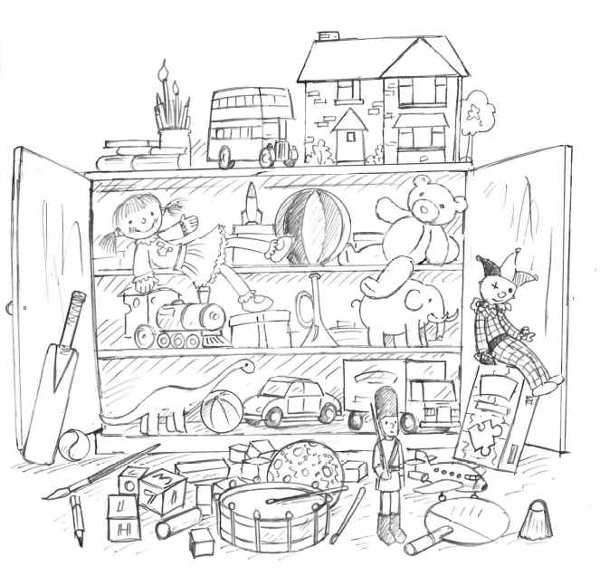

Which toys would you put in your cupboard?

