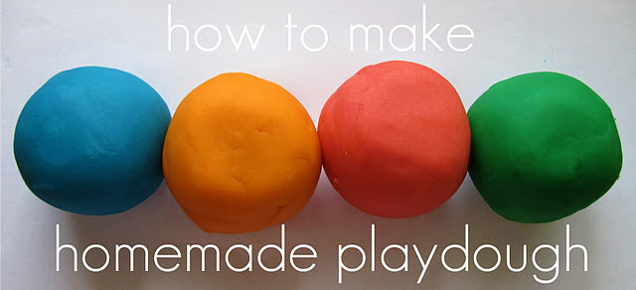
This Photo by Unknown Author is licensed under CC BY-SA-NC
You will need: -
2 cups water
2 cups flour
1 cup salt
2 tbs cooking oil
4 tsp cream of tartar
Food colouring (optional – try different colours)
To make: -
Mix and heat until ingredients together in a pan, stirring until they stick together to form a ball. Knead until smooth and store in airtight container.

