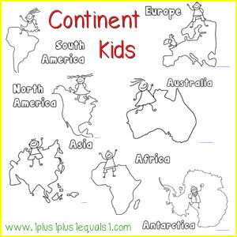

Colour the 7 different continents in 7 different colours.