What do plants need to grow?

Draw pictures to match the words

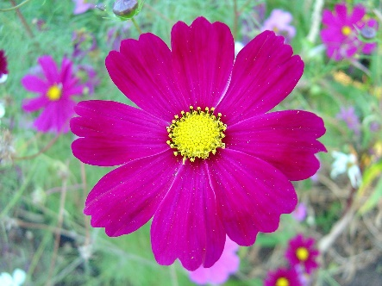

Flower

Soil

Water

Air

Sun